**Effect of Automatic Disinfection Box Using Ultra Violet Light on Microbial Growth of Microorganisms**

Jerico M. Clemente1, Aldrin O. Dizor2, Marife G. Gajelan3 , Joven R. Sabangan4

1Department of Computer Engineering/ Research Institute for Science and Technology, Polytechnic University of the Philippines, Philippines (Jerico M. Clemente, Aldrin O. Dizor, Marife G. Gajelan, Joven R. Sabangan)

2Department of Computer Engineering/ Research Institute for Science and Technology, Polytechnic University of the Philippines, Philippines

3Department of Computer Engineering/ Research Institute for Science and Technology, Polytechnic University of the Philippines, Philippines (Julius S. Cansino, Arvin R. De La Cruz)

***ABSTRACT***

*Researchers aim to determine the effectiveness of ultra violet lights in disinfecting using an automatic disinfection box. Researchers ought to find the significant difference for disinfecting between UV-based disinfectant and alcohol-based disinfectant, the significant effect of UV intensity, and the difference among the different duration in terms of its effectiveness. Researchers conduct streak plate and spread analysis on four similar pens under normal condition. Effectiveness of UV based and Alcohol based disinfectant were measured based on number of colonies in different treatments. Different treatments were replicated thrice and were compared to a baseline treatment wherein the agar plate was not exposed to UV or Alcohol. Gathered data are analyze using Two-sample & one-sample Wilcoxon test and Kruskal-Walis test. Four-point Likert scale are use to describe the device in terms of necessity, quality, price-quality ratio and approval. Results revealed that the baseline treatment was relatively higher compared to Alcohol based and UV based treatments. This suggests that Alcohol based and UV based disinfectant were more effective in terms of bacterial inhibition. Study shows that there is enough evidence to conclude that UV and Alcohol based disinfectant exhibit no significant difference when it comes to their effectiveness, UV intensity has a significant effect in terms of effectiveness, the different durations (10, 20, 30 seconds) of UV exposure show no significant difference in terms of effectiveness. Responses shows that the automatic disinfection meets current pandemic situation extremely well, has a very high quality, in terms of price has an above average value for money and the respondents are very satisfied using the device. The researchers recommend develop a real-time UVC dosage monitor module that shows the current UVC dosage of the device producing and a proper item counter.*

**1. INTRODUCTION**

In December of 2019 in Wuhan, China, an outbreak occurred due to the spread of the Novel Coronavirus. The virus spread at rapid rate and infect many people. Causing a great number of hospitalizations and casualties. The virus spread through-out the globe and recognized as global pandemic affecting more than 220 countries (Worldometer, 2021).

According to Kodoth et. Al. (2020), the society need to be cautious of other dangerous microorganisms that spread illness in addition to viruses. Humans are constantly in contact with germs and bacteria. Many surfaces and objects we come in contact with every day are covered in microorganisms that are potentially harmful to normal people with normal immunity. When poor hygiene habit is practiced, microorganisms can be passed from person to person (Francisco, 2022). These could potentially cause sickness and may escalate to something serious.

The Coronavirus cause a significant impact on disinfectant industry. Sudden rise in demand for sanitizers and disinfectant as a preventive measure against the virus has change the dynamic of the market (Reports and Data, 2020). The disinfectant demand imposes a challenge and concern to supply chain.

According to NationalAcademies (2021), ultraviolet lights specifically UVC, have the trait to inactivate SARS-CoV-2 and shows effectivity against reducing germs and inhibits microbial growth (Francisco, 2022). Cognizant of the growing problem, the researchers develop and design an automatic disinfecting box with UVC lamps as treating agent to disinfect materials and objects.

**1.1 Scope and Delimitation of the Study**

The device will have a dimension of 72cm in height, 84cm in length, and 54cm in width. The entrance clearance of the frame will have a dimension of 68cm in height and 78cm in width. The device will have a PIR sensor to detect if and object is ready inside the device.

The study will be limited to the comparison of effectiveness of ultraviolet-based disinfection with alcohol-based (70% alcohol content, isopropyl) disinfection, determining if there’s a significant effect of ultraviolet intensity to be use in terms of its effectiveness, determining the significant difference among the duration of 10 seconds, 20 seconds, and 30 seconds in terms of its effectiveness, and determining the overall user rating of the device in terms of necessity, quality, price-quality ratio and approval.

The study will be limited to the effect of automatic disinfection box using ultra violet light on microbial growth of microorganisms, not determining the microorganism that grow on the nutrient agar, and not determining the UVC dosage and irradiance of the automatic disinfection box.

The study will not cover the comparisons of effectiveness of ultraviolet-based disinfection and specific brands of alcohol. The study will not cover the comparisons of the effectiveness of ultraviolet-based disinfection and different alcohol content (beside 70% alcohol content) of specific brands of alcohol.

**1.2 Significance of the Study**

The Corona Virus Disease 2019 pandemic has increased the need for human disinfection. It is important to avoid reducing transmission risk. Thorough and efficient disinfection procedures must be implemented to return to our day-to-day operations cost-effectively. Humans are constantly in contact with germs and bacteria. Many surfaces and objects we come in contact with every day are covered in microorganisms that are potentially harmful to normal people with normal immunity according to Kodoth et. Al. (2020). When poor hygiene habit is practiced, microorganisms can be passed from person to person (Francisco, 2022). These could potentially cause sickness and may escalate to something serious. Cognizant of the growing problem of stress, this study will be significant to the following:

To the Users. Reduce potential risk of illness by promoting good hygiene practice and limiting your exposure to others’ germs critical for the user’s wellbeing. UV sterilization on objects effectively destroys bacteria and molds such as mites, E. coli, mucor, staphylococcus aureus etc.

To the Users Groups/Workmates. At the workplace, in the classroom, or in any space with heaps of foot traffic, germs spread rapidly, reduce transmission risk by destroying microbial growth on surfaces and inhibits from passing from one person to another. Eliminate germs occasionally for the duration of the day without leaving their study hall or work area. Eliminates harmful microorganisms from inanimate objects and surfaces such as documents, bags, parcels, etc.

To the Environment. This study recognized its unique position to help fight COVID-19 by and destroy microbial growth on microorganisms using its produce disinfection feature to disinfect. The Automatic Disinfection Box is a reusable disinfection device. This feature aids the environment by reducing plastic wastes from alcohol and sanitizer containers, the device promotes cleanliness and germicidal sanitizer prevents formation or reproduction of future causing disease.

To the Future Researchers. This study readily permits and encourage innovations. The study leads and inspires the future researchers to innovate disinfection technologies. The current researchers encourage the future researchers to rally this technology due to current pandemic.

**2. METHODOLOGY**

**2.1 Research Design**

The researchers use quantitative experimental research design for statement of the problem 1, 2 and 4 in the study. According to Bhandari 2021, quantitative experimental research systematically tests causal relationships, collect and analyze numerical data and generalize results. Qualitative research design is used for statement of the problem 3. According to Acasestudy (2020),” Qualitative research targets on conveying meaning and comprehension via detailed description”. The research designs will be used in the study.

Two-Samples Wilcoxon Test, One-Sample Wilcoxon Test, Kruskal-Walis Test, Four-point Likert scale are used for the statistical analysis of the study. Spread plate and streak plate microbiological culture technique are used in the field experiment. The alcohol sample for the experiment is 70% isopropyl alcohol.

The researchers formally give a letter of intents and asked Mr. Alberto De Guzman to be the beneficiary of the study. The researchers randomly selected 114 respondents by convenience sampling due to limitation of resources.

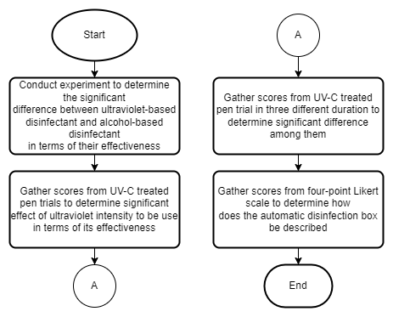

***Figure 2.1.1: Input-Process-Output (IPO) Model***

* 1. **Data Gathering**

The data for the statement of the problem number one are collected using a google form survey questionnaire after the device is implemented. The survey questionnaire created have questions modified from related research formed by the researchers. The survey covers the necessity, quality, price-quality ratio and approval. The survey was conducted for one month and the researcher’s assured confidentiality of their survey since the identities are not a requirement. The gathered data are used for the research after analyzing the survey answers.

* 1. **Software Application**

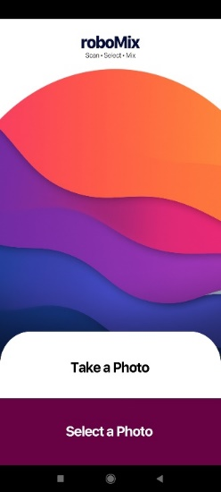 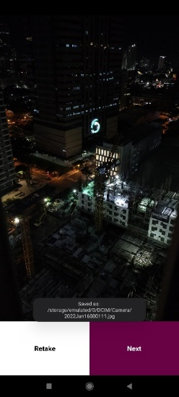 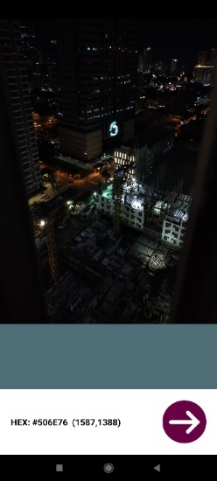 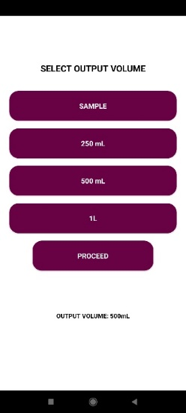

(a) (b) (c) (d)

***Figure 2.3.1. Mobile Application User Interface***

Figure 2.3.1 shows the major user interfaces in the mobile application. First, the user is given a choice between taking a live photo that will open the camera, or select a photo from their gallery (Figure 2.3.1.a). If the user opts to take a live photo, the camera application will open up and the user is able to capture an image. Once an image has been captured, the user can then proceed to the next step or retake an image (Figure 2.3.1.b). After selecting an image, either through live camera or the gallery, the user will then proceed to the pixel selection stage, where they can select a point in the image. The point is a pixel on the image, and the hex color value, as well as the coordinates of the pixel, is then displayed (Figure 2.3.1.c). Once satisfied with the color, the user then proceeds to the selecting the amount of paint to be dispensed (Figure 2.3.1.d). After the user proceeds, the information is sent to the Arduino Mega in the machine via Bluetooth connection.

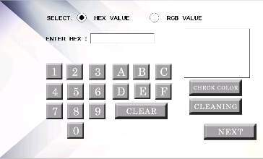 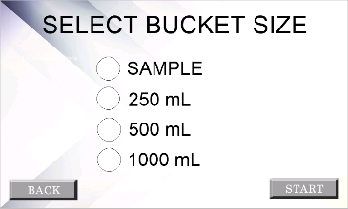

(a) (b)

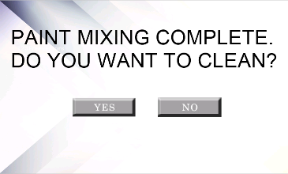 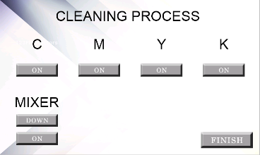

(c) (d)

***Figure 2.3.2. Nextion LCD User Interface***

The figure above displays the major interfaces for the Nextion touchscreen LCD. The device allows the user to manually input their desired color. The user is allowed to input either hex value or the RGB values using a custom virtual keypad (Figure 2.3.2.a). They are also allowed to go directly into cleaning mode. Similar to the mobile application, the user has a selection of output paint sizes to choose from (Figure 2.3.2.b). After the machine has completed the mixing process, the user is prompted whether they desire to undergo the cleaning process (Figure 2.3.2.c). It is important to note that the user should proceed with the cleaning process on a regular basis to avoid the drying of the paint inside the tubes. The cleaning process involves the manual activation of the pumps and the mixer, assuming that the input paint buckets are replaced with water for cleaning (Figure 2.3.2.d).

**2.4 Hardware Components**

The figure below shows the CAD design of the machine. The largest dimensions are 24 inches by 24 inches by 30 inches.

 

(a) (b)

 

(c) (d)

***Figure 2.4.1. Computer Aided Draft Design of the Prototype***

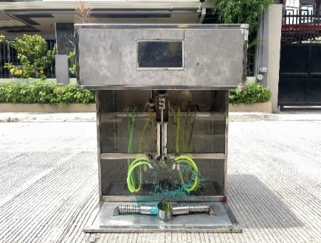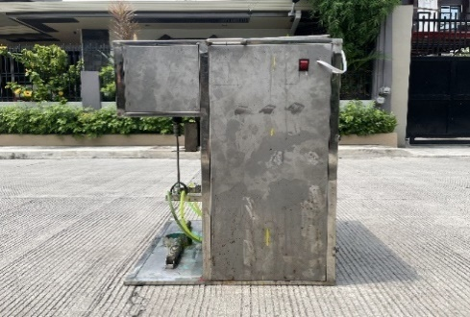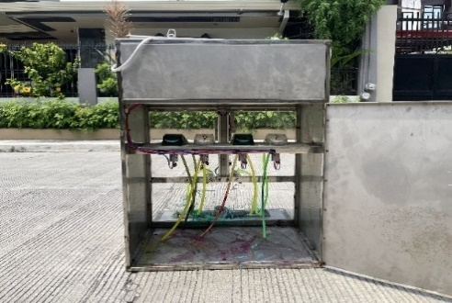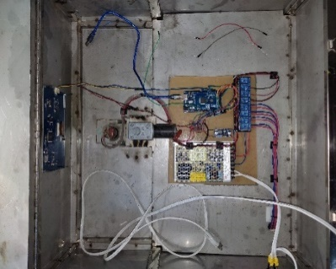

(a) (b) (c) (d)

***Figure 2.4.2. Actual Machine Prototype***

Shown in Figure 2.4.2 is the actual machine prototype. The machine is made from stainless steel to prevent corrosion. The front has a transparent plastic shielding, making it possible to view the pumps and the paint buckets. The level hose connects the input paint buckets to the pumps and out into the mixing container. The side of the machine has a rocker switch that enables powering the machine on and off (Figure 2.4.2.b). The back side has a compartment that holds the input CMY paint buckets, as well as the peristaltic pumps. The top compartment of the machine holds the microcontroller and other electronic components that enables and directs the machine (Figure 2.4.2.d). The major components of the machine include the Arduino Mega, Nextion LCD, power supply, relays, and DC motors.

**2.5 Machine Diagrams**

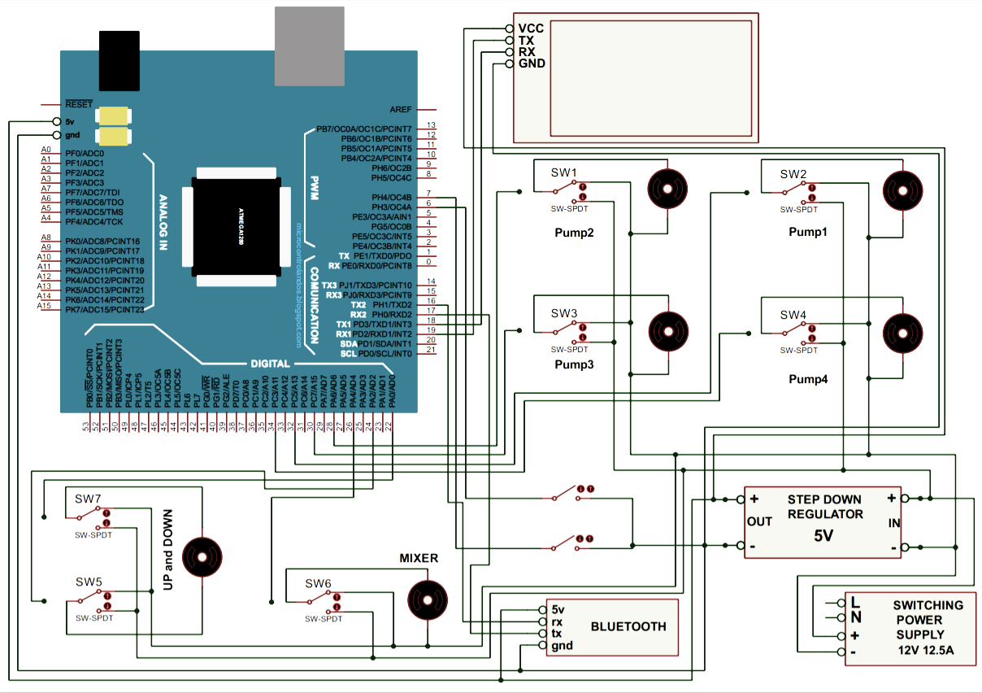

***Figure 2.5.1. Schematic Diagram of the Arduino MEGA to the Other Components***

The figure above presents the machine’s schematic diagram. The 12V power supply is connected to a step-down regulator that transforms the 12V input down to 5V. This 5V is used to directly power the Arduino Mega, which is the microcontroller of the circuit, the LCD, and the Bluetooth module. This is due to the maximum voltage limitation these components can handle, which is 5V. On the other hand, the peristaltic pumps and the DC motors are directly connected to the power supply via relay switches, which receive 12V directly in order to sustain their rotation. From there on, the Arduino Mega uses a 5V supply to trigger the relay switches, turning them on or off depending on its calculations and logic.

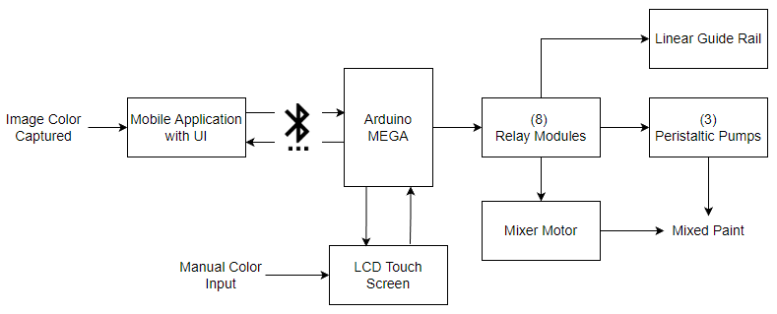

***Figure 2.5.2. Block Diagram of the System***

Figure 2.5.2 above is the block diagram of the machine. Based on the figure, there are two ways to input data into the machine, one via the mobile application, and another one via manual input on the touchscreen LCD. From the mobile application, data is sent via Bluetooth to the Arduino Mega, and the microcontroller is responsible for triggering the relay modules, which in turn activates or deactivates the corresponding component connected to it, which are the three peristaltic pumps connected to the input paint supply, the linear guide rail responsible for the upwards and downwards motion of the mixer, and the actual mixer motor responsible for the rotation of the whisk. After the process, a mixed paint is produced as an output of all the calculations made.

**3. RESULTS AND DISCUSSION**

**3.1 Perceived Accuracy**

***Table 3.1.1. Evaluation of Perceived Accuracy by the Respondents***



In Table 3.1.1, the Ordinary Users (OU) and the Technical Specialists (TS) were tasked to compare two colors, the actual input color and the output paint color of the system. The respondents were not given the color values, and instead used their perception to rate the similarity of the two using a Likert scale. The colors compared were chosen at random. The ordinary users gave average scores of 4.51, 4.46, 3.95, 3.71, and 3.49 for each sample, respectively. Meanwhile, the technical specialists conferred average scores of 4.33, 4.00, 3.67, 3.50, and 3.33 for each sample, respectively. The overall scores were interpreted, ranging from a slightly similar interpretation to a slightly dissimilar interpretation. Particularly, the last two colors comparison items scored a slightly dissimilar interpretation, the third item acquired a neutral similarity, and the first two items gathered a slightly similar interpretation result.

Based on their overall scores, the ordinary users score was interpreted to be having a slightly similar perception, while the technical specialists score was interpreted to be having a neutral similarity based on all samples. The data from this survey was then subjected to a Welch’s T-test, obtaining a t-value of 0.9103. The degrees of freedom (df) of the sample is six, and the critical value is 2.447. Because the t-value is less than the critical value, the researchers fail to reject the null hypothesis. This indicates that there is a general agreement between the two groups of respondents on the perceived similarity of the colors.

**3.2 Color Detection Accuracy**

***Table 3.2.1. Mobile Application Color Detection Accuracy***



In Table 3.2.1, two images were taken at similar settings, each using a different camera resolution. Five different pixel points on the image were selected at random, and the detected color values were recorded. These values were later compared to their actual color values to determine the accuracy. The 13 MP resolution acquired an average accuracy of 99.19% and 99.22% for each of the images. The 19 MP resolution obtained an average accuracy of 99.45% and 99.35% for each of the images. And lastly, the 64 MP resolution received an average accuracy of 99.90% and 99.79% for each of the images. Overall, all average accuracies were above 99% when compared to the actual color values.

**3.3 Scanned Color vs Output Paint Color**

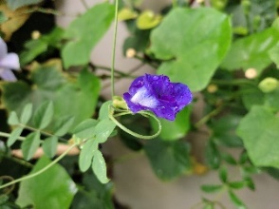 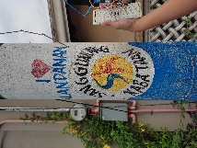

(a) (b)

***Figure 3.3.1. Images Used for Comparison***

The images above were captured through the mobile application using a 13 MP camera resolution with similar lighting conditions. These are used for the comparison between the color detected and the output paint color.

***Table 3.3.1. Comparison Between Color Detection And Output Paint Color for Figure 3.3.1.a***



***Table 3.3.2. Comparison Between Color Detection And Output Paint Color for Figure 3.3.1.b***



The two tables above summarize the results of the comparison between the scanned color and the output paint color of the system. For each of the figures in Figure 8, five pixels were randomly selected on the image. The coordinates of these pixels were recorded, along with the color values detected. The color values were sent to the machine to undergo the mixing process to create the colored paint. Once the mixing process is completed, the paint is then applied to a white paper, and then dried. After which, the color values between the scanned color and output color were then compared. The overall accuracy obtained were 87.11% for Figure 8.a, and 87.40% for Figure 8.b. The lowest accuracies were 81.31% and 80.13%, respectively. The accuracy results were above 85%, and can be interpreted as a satisfactory outcome.

**3.4 ISO 25010**

***Table 3.4.1. Evaluation of Respondents Using the ISO 25010 Standard***



The table above summarizes the results of the survey from two respondents, ordinary users and technical specialists. The ordinary users that participated in the study gave a general mean of 3.38 for all criteria, which is interpreted as a generally agreeing score. Similarly, the technical specialists also gave a generally agreeing score of 3.29. The t-value was then calculated based on the scores for each criterion, with functional suitability gaining 1.0274, performance efficiency with 0.9031, usability obtaining 1.0267, reliability gathered a t-value of 1.2401, and portability with 0.5190. The df was also calculated, and the critical value for each criterion was obtained in the t-distribution table. Comparing the t-value and the critical value, all criteria indicated the failure to reject the null hypothesis. There is a unified agreement between the respondents on their evaluation of the system based on the ISO 25010 standard.

# 4. SUMMARY, CONCLUSION, AND RECOMMENDATIONS

**4.1 Conclusion**

The following conclusion were made based on the findings, proof of effectivity of the device such as certificate of analysis of Automatic Disinfection Box and Certification of Statistical Treatment

There is enough evidence to conclude that UV and Alcohol based disinfectant exhibit no significant difference when it comes to their effectiveness. UV intensity has a significant effect in terms of effectiveness and this result supports the comparison of findings of Baseline treatment and UV based treatments in terms of bacterial inhibition since number of colonies from UV based treatments were lower than those from the former, and the different durations of UV exposure of 10, 20, 30 seconds show no significant difference in terms of effectiveness.

Based on the statistical analysis, the automatic disinfection meets current pandemic situation extremely well, the automatic disinfection box has a very high quality in terms of quality, have an above average price-quality price ratio and the respondents are very satisfied using the automatic disinfection box.

**4.2 Recommendation**

The researchers recommend the following suggestions to further develop and revolutionize the study.

1. Make a real-time UVC dosage monitor module that shows the current UVC dosage of the device producing.
2. Develop a BIOS of the system to save the current settings, device health, UVC lamp life.
3. Improve by letting maintainer input their mobile phone number where the device is going to send the message. The length of the message can also be improved by adding more information to the message.
4. Add feature that when the registered number of the device received a “STATUS” the device will send the current status of the device.
5. Expand device by a self-disinfect feature on the device handles to reduce transmission of virus and microorganisms.
6. Construct buttons to the device like power switch to make it more intuitive.

**5. REFERENCES**

1. Acasestudy (2021). What is qualitative research design? Methods and types. Retrieved from https://acasestudy.com/what-is-qualitative-research-design-methods-and-types/
2. AIS (2022). How to choose the right beam angle for LED lights. Retrieved from https://www.aisledlight.com/choose-right-beam-angle-led-lights/
3. Aisha et. Al (2018). Effect of ultraviolet radiation on the growth of microorganisms developing on cave wall paintings. Retrieved from https://aip.scitation.org/doi/abs/10.1063/1.5048178?journalCode=apc#:~:text=UV%2DC%20at%20a%20wavelength,the%20end%20of%20the%20treatment.
4. Alba et. Al. (2021). Microbiological Evaluation of the Disinfecting Potential of UV-C and UV-C Plus Ozone Generating Robots. Retrieved from https://www.mdpi.com/2076-2607/9/1/172
5. American Ultraviolet. frequently Asked Questions about UVC. Retrieved from https://www.americanultraviolet.com/germicidal-healthcare-solutions/frequently-asked-questions-about-UVC.html
6. Arduino.cc (2022). UNO R3. Retrieved from https://docs.arduino.cc/hardware/uno-rev3
7. Baes, F. (n.d.). Hps.org. Health Physics Society. Retrieved July 24, 2022, from https://hps.org/publicinformation/ate/q9450.html
8. Barnard et. Al. (2020). Further Evidence That Far-UVC for Disinfection Is Unlikely to Cause Erythema or Pre-Mutagenic DNA Lesions in Skin. Retrieved from https://doi.org/10.1111/phpp.12580.
9. Bhandari P. (2020). An introduction to quantitative research. Retrieved from https://www.scribbr.com/methodology/quantitative-research/
10. Brenner D. (2020). Far-UVC Light to Limit Airborne Transmission of SARS-CoV-2 … and All Other Viruses. Retrieved from https://www.nationalacademies.org/event/09-16-2020/the-second-gilbert-w-beebe-webinar-safety-and-efficacy-of-uvc-to-fight-covid-19.
11. Buonanno, M. (2020, December 23). Far-UVC light (222ânm) efficiently and safely inactivates airborne human coronaviruses. Scientific Reports. Retrieved from https://www.nature.com/articles/s41598-020-67211-2
12. Buonanno, M. et. Al. (2019). Germicidal Efficacy and Mammalian Skin Safety of 222-nm UV Light. Retrieved from https://doi.org/10.1667/RR0010CC.1.
13. Buonanno, M. et. Al. (2020). Far-UVC Light (222 nm) Efficiently and Safely Inactivates Airborne Human Coronaviruses. Retrieved from https://doi.org/10.1038/s41598-020-67211-2.
14. Casini, B., & Tuvo, B. (2019, September 24). Evaluation of an ultraviolet C (UVC) light-emitting device for disinfection of high touch surfaces in hospital critical areas. International journal of environmental research and public health. Retrieved July 25, 2022, from https://www.ncbi.nlm.nih.gov/pmc/articles/PMC6801766/
15. Cesarini, J.-P. (2019). UV-C photocarcinogenesis risks from germicidal lamps. CIE. Retrieved July 25, 2022, from https://cie.co.at/publications/uv-c-photocarcinogenesis-risks-germicidal-lamps
16. Childress J. (March 22, 2021). Using 222-nm Ultraviolet (UV) Light for Safer Disinfection. Retrieved from https://www.dsiac.org/resources/articles/using-222-nm-ultraviolet-uv-light-for-safer-disinfection/
17. Dahal (2022). Spread Plate Method- Definition, Principle, Procedure, Uses. Retrieved from https://microbenotes.com/spread-plate-technique/
18. Dahal (2022). Streak Plate Method- Principle, Types, Methods, Uses. Retrieved from https://microbenotes.com/streak-plate-method-principle-methods-significance-limitations/
19. DOST (May 22, 2020). DOST-X, PARAS JOIN HANDS IN DEVELOPING PARAZAP DISINFECTION UNIT FOR COVID-19. Retrieved from https://www.dost.gov.ph/knowledge-resources/news/67-2020-news/1823-dost-x-paras-join-hands-in-developing-parazap-disinfection-unit-for-covid-19.html
20. Electronicsforu.com (2021). All You Wanted to Know About GSM Module and GPRS Module. Retrieved from https://www.electronicsforu.com/resources/gsm-module
21. Eubanas G. et. Al. (2021, February 26). Are ultraviolet lamps effective in infection prevention and control of COVID-19 infections in public spaces in locations with sustained community transmission? Retrieved from https://www.psmid.org/wp-content/uploads/2021/04/NPI_UV-Lamps_20210405.pdf
22. FDA. (2020). Ultraviolet (UV) radiation. U.S. Food and Drug Administration. Retrieved July 25, 2022, from https://www.fda.gov/radiation-emitting-products/tanning/ultraviolet-uv-radiation
23. Felco Store (2022). Firefly Yellow Shield Antivirus & Germicidal UV Tube Set. Retrieved from https://www.felcostore.ph/products/firefly-yellow-shield-antivirus-germicidal-uv-tube-set?variant=42080995639460
24. Felcostore.ph (2022). Firefly Yellow Shield Antivirus & Germicidal UV Tube Set. Retrieved from https://www.felcostore.ph/products/firefly-yellow-shield-antivirus-germicidal-uv-tube-set
25. Geiger D. (2020). UV Light Helps Duke Hospitals Fight Transmission of Superbugs. Retrieved from https://www.dukehealth.org/blog/uv-light-helps-duke-hospitals-fight-transmission-of-superbugs
26. Griffiths, A. (2022, June 30). UV-C dose required to kill microorganisms. UV Light Technology. Retrieved July 24, 2022, from https://uv-light.co.uk/uv-dosage-required-to-kill-microorganisms/
27. Heilingloh, C. S., Aufderhorst, U. W., & Schipper, L. (2020, August 4). Susceptibility of SARS-COV-2 to UV irradiation. American Journal of Infection Control. Retrieved July 24, 2022, from https://www.ajicjournal.org/article/S0196-6553(20)30756-2/fulltext
28. Jamieson S. (2022). Likert Scale. Retrieved from https://www.britannica.com/topic/Likert-Scale
29. Kitagawa et. Al. (2020). Effectiveness of 222-nm Ultraviolet Light on Disinfecting SARS-CoV-2 Surface Contamination. Retrieved from https://doi.org/10.1016/j.ajic.2020.08.022.
30. Kodoth et. Al. (2020). The Effects of Ultraviolet Light on Escherichia coli. Retrieved from https://emerginginvestigators.org/articles/the-effects-of-ultraviolet-light-on-em-escherichia-coli-em
31. Kosta G. (2020). UV-C Penetrable Plastic & Materials. Retrieved from https://start.askwonder.com/insights/uv-c-penetrable-plastic-and-materials-2-5li2z1mx1
32. Lamp HQ (2022). LED Beam Angle Guide – With Beam Angle Calculator. Retrieved from https://lamphq.com/beam-angle/
33. lastminuteengineers.com (2022). Interface One Channel Relay Module with Arduino. Retrieved from https://lastminuteengineers.com/one-channel-relay-module-arduino-tutorial/
34. lastminuteengineers.com (2022). Send Receive SMS & Call with SIM900 GSM Shield & Arduino. Retrieved from https://lastminuteengineers.com/sim900-gsm-shield-arduino-tutorial/
35. LightSources. (2022, January 2). Does UV light kill covid-19? LightSources. Retrieved July 24, 2022, from https://www.light-sources.com/blog/does-uv-light-kill-covid/
36. Merriam-webster (2021). Germicidal. Retrieved from https://www.merriam-webster.com/dictionary/germicidal
37. Merriam-webster (2021). In vitro. Retrieved from https://www.merriam-webster.com/dictionary/in%20vitro
38. Merriam-webster (2021). Irradiation. Retrieved from https://www.merriam-webster.com/dictionary/irradiation
39. Minnesota Department of Health (2022). About Staphylococcus aureus. Retrieved from https://www.health.state.mn.us/diseases/staph/basics.html#:~:text=aureus%20is%20spread%2C%20common%20symptoms,infections%20are%20not%20serious%2C%20S
40. Miranda et. Al. (2020, October 21). Analysis of UV technologies for disinfection of public areas: a systematic literature review. Retrieved from https://ieeexplore.ieee.org/abstract/document/9253754?fbclid=IwAR2ZIPL8WVGAXAzu379fXSjJ6rwLkVijhjGHk1Bo6ucP3jneVs5suzv99Yo
41. NationalAcademies (2021). Does ultraviolet kill the coronavirus? Retrieved from https://www.nationalacademies.org/based-on-science/covid-19-does-ultraviolet-light-kill-the-coronavirus
42. NCI Dictionary of Cancer terms. National Cancer Institute. (2022). Microorganism. Retrieved from https://www.cancer.gov/publications/dictionaries/cancer-terms/def/microorganism
43. Oguma et. Al. (2020). Photoreactivation of Escherichia Coli After Low- or Medium-Pressure UV Disinfection Determined by an Endonuclease Sensitive Site Assay. Retrieved from https://doi.org/10.1128/aem.68.12. 6029-6035.2002.
44. Oxford English Dictionary (2020). "Covid-19". Retrieved from https://www.oxfordlearnersdictionaries.com/us/definition/english/covid-19
45. Pelczar, M. (2022). The study of Microorganisms. Encyclopedia Britannica. Retrieved from https://www.britannica.com/science/microbiology/The-study-of-microorganisms
46. PHILIPPINE DERMATOLOGICAL SOCIETY PHOTODERMATOLOGY SUBSPECIALTY CORE GROUP. (2020, July). GUIDELINES ON UV DISINFECTION. Retrieved from https://pds.org.ph/pds_new/wp-content/uploads/2020/06/UV-Disinfection-Guidelines-PDS-06112020-FINAL.pdf
47. Ploydaeng et. Al. (2020). UV-C light: A powerful technique for inactivating microorganisms and the related side effects to the skin. Retrieved from https://onlinelibrary.wiley.com/doi/10.1111/phpp.12605
48. Pullerits et. Al (2020). Impact of UV irradiation at full scale on bacterial communities in drinking water. Retrieved from https://www.nature.com/articles/s41545-020-0057-7
49. QuestionPro (2022). Types of Sampling: Sampling Methods with Examples. Retrieved from https://www.questionpro.com/blog/types-of-sampling-for-social-research/
50. Ramos C. et. Al. (2020, November 14). Use of ultraviolet-C in environmental sterilization in hospitals: A systematic review on efficacy and safety. Retrieved from https://www.ncbi.nlm.nih.gov/pmc/articles/PMC7644456/?fbclid=IwAR3_L3UDxff7C4FMC9y1SMXL-QtE87HGos9iSe1Say9nFvZ7C-54GVSEddY
51. Resonance Ltd. (2021). "What is an Excimer Lamp?". Retrieved from http://resonance.on.ca/excimer.htm
52. Sciencedirect (2022). Passive Infrared Sensor. Retrieved from https://www.sciencedirect.com/topics/computer-science/passive-infrared-sensor
53. Sciencedirect.com (2022). Copper wire. Retrieved from https://www.sciencedirect.com/topics/engineering/copper-wire
54. Sharma (2022). Kirby Bauer Disc Diffusion Method For Antibiotic Susceptibility Testing. Retrieved from https://microbenotes.com/kirby-bauer-disc-diffusion/
55. sparkfun.com (2022). Resistors. Retrieved from https://learn.sparkfun.com/tutorials/resistors/all#
56. Staff. (2020, September 14). What is the difference between UVA UVB UVC? which is most dangerous? LED Lighting Distributor and Implementation Company. Retrieved July 24, 2022, from https://www.stouchlighting.com/blog/uva-uvb-uvc-differences
57. Taylor et. Al. (2019). Effectiveness of UV-C light irradiation on disinfection of an eSOSÂ® smart toilet evaluated in a temporary settlement in the Philippines. (2016). Retrieved from https://www.tandfonline.com/doi/abs/10.1080/09603123.2016.1217313
58. Technopedia.com (2017). LED Display. Retrieved from https://www.techopedia.com/definition/14957/led
59. Technopedia.com (2017). Power supply. Retrieved from https://www.techopedia.com/definition/1756/powersupply#:~:text=A%20power%20supply%20is%20a,provides%20components%20with%20electric%20power
60. Thefreedictionary.com (2021). UVB. Retrieved from https://medical-dictionary.thefreedictionary.com/UVB
61. Tyrell, D. (2020, March 10). Coronaviruses - Medical Microbiology - NCBI Bookshelf. Medical Microbiology. 9th Edition. Retrieved from https://www.ncbi.nlm.nih.gov/books/NBK7782/
62. U.S Food and Drug Administration (2022). UV Lights and Lamps: Ultraviolet-C Radiation, Disinfection, and Coronavirus. Retrieved from https://www.fda.gov/medical-devices/coronavirus-covid-19-and-medical-devices/uv-lights-and-lamps-ultraviolet-c-radiation-disinfection-and-coronavirus
63. Ultraviolet (UV) radiation. American Cancer Society. (2019). Retrieved July 25, 2022, from https://www.cancer.org/healthy/cancer-causes/radiation-exposure/uv-radiation.html
64. Violet Defense (2020). Understanding the Power of Light to Kill Germs. Retrieved from https://www.violetdefense.com/howitworks
65. Walker D. et. Al. (2019). Effect of Ultraviolet Germicidal Irradiation on Viral Aerosols. Retrieved from https://doi.org/10.1021/es070056u.
66. Worldometer (July 2021). COVID-19 CORONAVIRUS PANDEMIC. Retrieved from https://www.worldometers.info/coronavirus/
67. Yamano N. et. Al. (2020). Long-Term Effects of 222-nm Ultraviolet Radiation C Sterilizing Lamps on Mice Susceptible to Ultraviolet Radiation. Retrieved from https://doi.org/10.1111/PHP.13269.
68. Yang et. Al. (2019). Effectiveness of an ultraviolet-C disinfection system for reduction of healthcare-associated pathogens. Retrieved from https://pubmed.ncbi.nlm.nih.gov/28951015/
69. Yang, J.-H., Wu, U.-I., Tai, H.-M., & Sheng, W.-H. (2019, September 18). Effectiveness of an ultraviolet-C disinfection system for reduction of healthcare-associated pathogens. Journal of Microbiology, Immunology and Infection. Retrieved July 24, 2022, from https://www.sciencedirect.com/science/article/pii/S1684118217302001

**ACKNOWLEDGEMENTS**

**APPENDICES**

**Appendix 1: Letter of Intent**

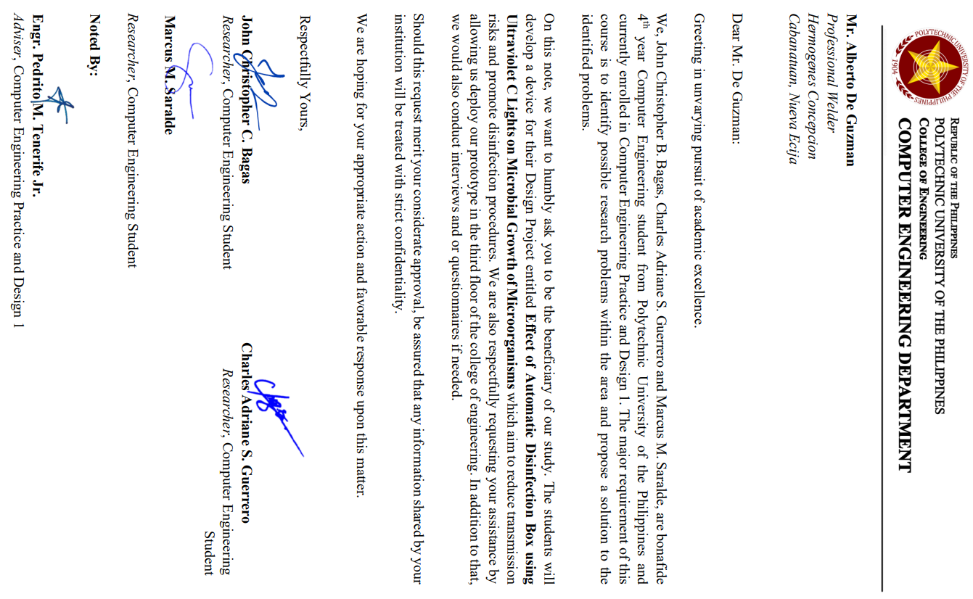

**Appendix 2: Design Project Proposal Defense 2021**

DESIGN PROJECT PROPOSAL DEFENSE 2021

SUMMARY OF COMMENTS

REPORT

**NO.:** CPERC-2021-PROP-POE-R-000060

|  |  |  |  |  |
| --- | --- | --- | --- | --- |
| **GROUP CODE** |  | 3609 | **ADVISER** | Engr. Pedrito M. Tenerife Jr. |
| **SECTION** |  | BSCpE 3-6 |
|  |  |  | | |
| **THESIS TITLE** |  | Development of Automatic Covid Disinfection Box Implemented with Arduino (ADB Automatic Disinfection Box) | | |

|  |  |
| --- | --- |
|  | **NAME OF PANEL** |
| **PANEL CHAIR** | Dr. Remedios G. Ado |
| **PANEL MEMBER 1** | Engr. Arlene B. Canlas |
| **PANEL MEMBER 2** | Engr. Jonathan C. Manarang |

|  |  |  |
| --- | --- | --- |
|  | **COMMENTS** | **RECOMMENDATIONS** |
| **PANEL CHAIR** | Consider the comments and suggestions of the panel of evaluator to improve the project. | think of an alternative application solution to justify the need of this project & with 4 members in a team. |
| **PANEL MEMBER 1** |  | Consider adding how to verify the effectivity/ effectiveness of your disinfection device. Maximize the use of Arduino (example: sending sms about the status of the disinfection and the device) |
| **PANEL MEMBER 2** | Add gsm shield for sending message to the owner of the item being sanitized. Apply this prototype to laboratory subjects, include the counting of object being sanitized. Provide clinical lab test result in front of your subject to denote that it is calibra. |  |

**NOTE:** The data shown above are acquired from the filled-out Panel Evaluation Form in Google Forms. Should there be any error on this report, please notify the CpE Research Committee for verification.

**Appendix 3: Letter of Permission to**

**Conduct Experiment**

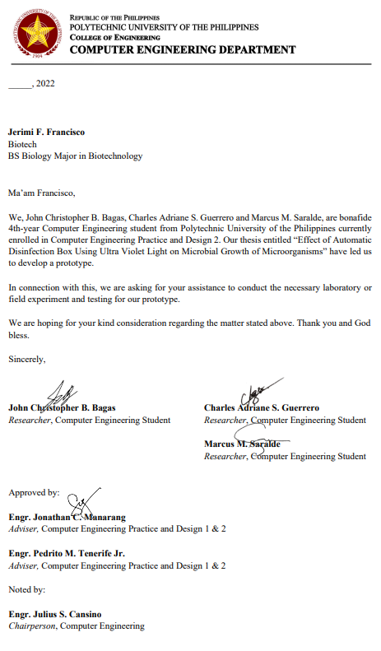

**Appendix 4: Initial Draft**

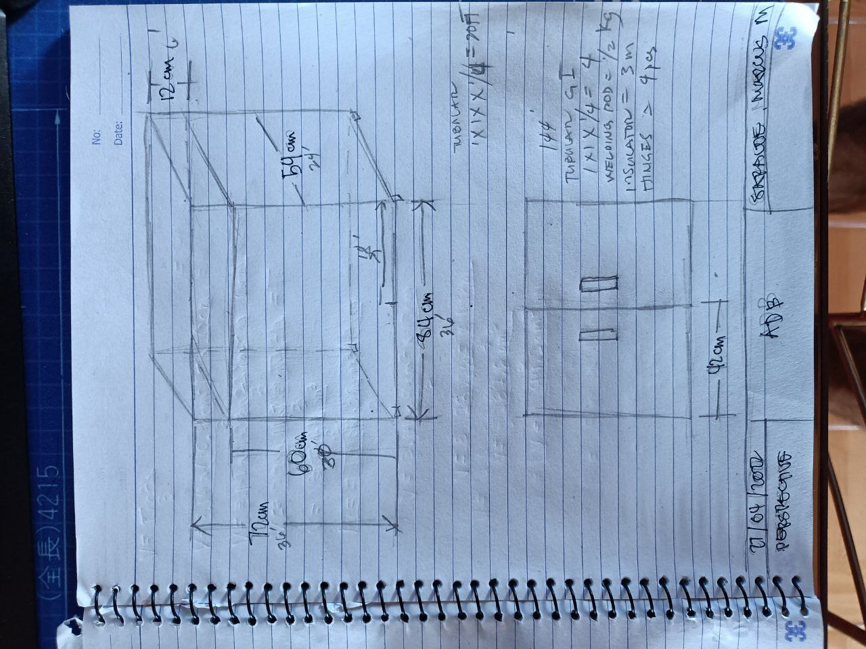

**Appendix 5: Survey and Four Point Likert Scale**

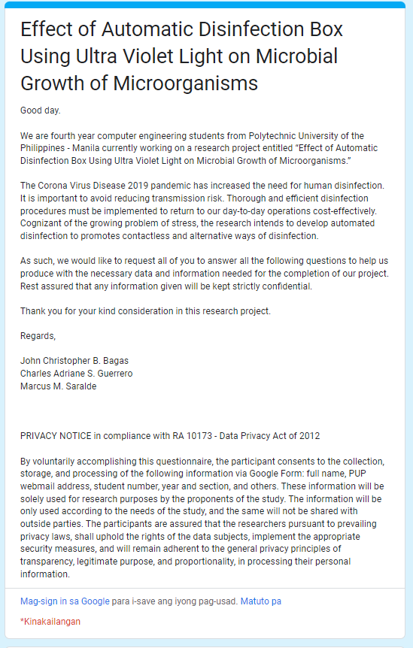

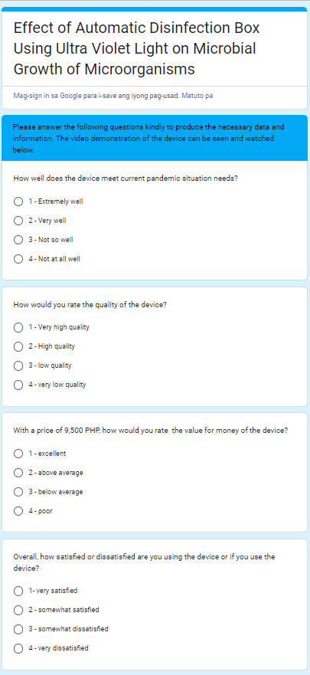

**Appendix 6: Source Code**

#include <Wire.h>

#include <SoftwareSerial.h>

#include <LiquidCrystal_I2C.h>

SoftwareSerial mySerial(9,10);

char msg;

char call;

LiquidCrystal_I2C lcd(0x27, 16, 2);

int ledPin = 3;

int buzzer = 2;

byte zero[] = {

B00000,

B00000,

B00000,

B00000,

B00000,

B00000,

B00000,

B00000

};

byte one[] = {

B10000,

B10000,

B10000,

B10000,

B10000,

B10000,

B10000,

B10000

};

byte two[] = {

B11000,

B11000,

B11000,

B11000,

B11000,

B11000,

B11000,

B11000

};

byte three[] = {

B11100,

B11100,

B11100,

B11100,

B11100,

B11100,

B11100,

B11100

};

byte four[] = {

B11110,

B11110,

B11110,

B11110,

B11110,

B11110,

B11110,

B11110

};

byte five[] = {

B11111,

B11111,

B11111,

B11111,

B11111,

B11111,

B11111,

B11111

};

void setup() {

digitalWrite(4, HIGH);

delay(1000);

digitalWrite(4, LOW);

delay(5000);

lcd.init();

lcd.backlight();

digitalWrite(ledPin, HIGH);

pinMode(ledPin, OUTPUT);

pinMode (buzzer, OUTPUT);

lcd.createChar(0, zero);

lcd.createChar(1, one);

lcd.createChar(2, two);

lcd.createChar(3, three);

lcd.createChar(4, four);

lcd.createChar(5, five);

mySerial.begin(9600);

Serial.begin(9600);

}

void loop() {

int pirState=digitalRead(6);

if (pirState == LOW) {

lcd.setCursor(0,0);

lcd.print("PUT OBJECT");

lcd.setCursor(0,1);

lcd.print("TO DISINFECT");

delay(500);

}

else if (pirState == HIGH) {

delay(3000);

lcd.clear();

lcd.setCursor(0,0);

lcd.print("DISINFECTING:");

delay(500);

digitalWrite(ledPin, LOW);

for(int i=0; i <= 100; i++) {

lcd.setCursor(0,1);

updateProgressBar(i, 100, 1);

delay(100);

}

delay(1000);

lcd.clear();

lcd.setCursor(0,0);

lcd.print("DONE!!!!");

digitalWrite(ledPin, HIGH);

digitalWrite(buzzer, HIGH);

delay(1000);

digitalWrite(buzzer, LOW);

delay(1000);

digitalWrite(buzzer, HIGH);

delay(1000);

digitalWrite(buzzer, LOW);

delay(1000);

digitalWrite(buzzer, HIGH);

delay(1000);

digitalWrite(buzzer, LOW);

SendMessage();

lcd.clear();

lcd.setCursor(0,0);

lcd.print("DISINFECTION");

lcd.setCursor(0,1);

lcd.print("COMPLETE");

delay(2000);

lcd.clear();

lcd.setCursor(0,0);

lcd.print("PLEASE REMOVE");

lcd.setCursor(0,1);

lcd.print("OBJECT NOW 5");

delay(1000);

lcd.setCursor(0,0);

lcd.print("PLEASE REMOVE");

lcd.setCursor(0,1);

lcd.print("OBJECT NOW 4");

delay(1000);

lcd.setCursor(0,0);

lcd.print("PLEASE REMOVE");

lcd.setCursor(0,1);

lcd.print("OBJECT NOW 3");

delay(1000);

lcd.setCursor(0,0);

lcd.print("PLEASE REMOVE");

lcd.setCursor(0,1);

lcd.print("OBJECT NOW 2");

delay(1000);

lcd.setCursor(0,0);

lcd.print("PLEASE REMOVE");

lcd.setCursor(0,1);

lcd.print("OBJECT NOW 1");

delay(1000);

lcd.setCursor(0,0);

lcd.print("PLEASE REMOVE");

lcd.setCursor(0,1);

lcd.print("OBJECT NOW 0");

delay(1000);

lcd.clear();

digitalWrite(pirState, LOW);

delay(5000);

}

}

void updateProgressBar(unsigned long count, unsigned long totalCount, int lineToPrintOn) {

double factor = totalCount/80.0;

int percent = (count+1)/factor;

int number = percent/5;

int remainder = percent%5;

if(number > 0) {

lcd.setCursor(number-1,lineToPrintOn);

lcd.write(5);

}

lcd.setCursor(number,lineToPrintOn);

lcd.write(remainder);

}

void SendMessage()

{

mySerial.println("AT+CMGF=1");

delay(1000);

mySerial.println("AT+CMGS=\"+639750710500\"\r");

delay(1000);

mySerial.println("DISINFECTED");

delay(100);

mySerial.println((char)26);

delay(1000);

**Appendix 7: Bill of Materials**

|  |  |  |
| --- | --- | --- |
| **Item** | **Quantity** | **Price** |
| Angle bar, cutting disk, welding rod, rubber wheels | 1 | 1690 |
| Galvanized Steel sheet .9 (4x8) | 1 | 1200 |
| Flat bar kilo | 5 | 200 |
| Insulation and stainless handles | 1 | 350 |
| Clear coat | 1 | 120 |
| Rugby, | 1 | 70 |
| Roller Catches | 4 | 205 |
| Labor assistance | 1 | 1000 |
| 1/4 thick glass | 1 | 200 |
| Steel Matting | 1 | 430 |
| Bosny Spray Paint White | 6 | 600 |
| Fyl201 | 1 | 1700 |
| Petri dish | 20 | 202 |
| Premixed nutrient agar | 1 | 257 |
| Cling wrap | 1 | 79 |
| Cotton swab | 1 | 54 |
| 16*2 LCD Display i2c | 1 | 146 |
| Arduino Uno r3 kit | 1 | 1200 |
| Sim900A | 1 | 270 |
| Total | | 9,973.00 |

**Appendix 8: Letter of Permission to**

**Rename Study**

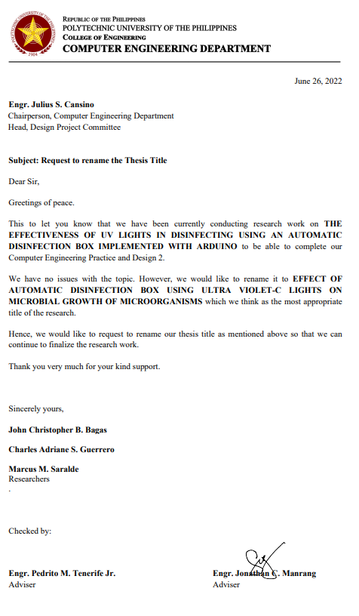

**Appendix 9: Certificate of Analysis**

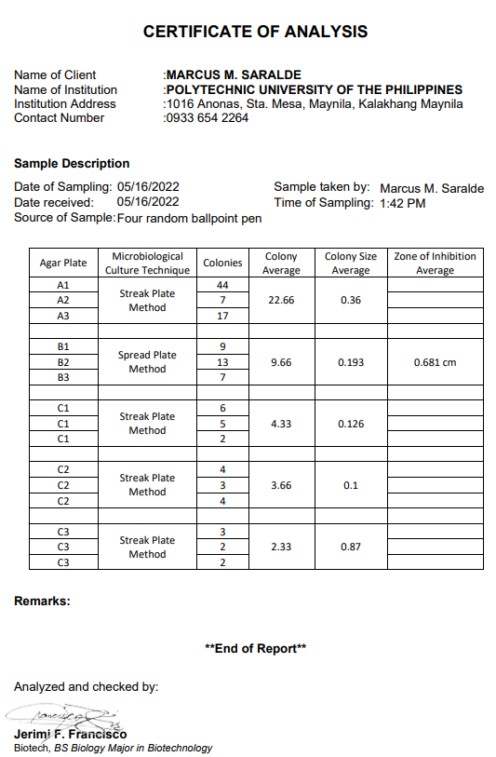

**Appendix 10: Certification of Statistical Treatment**

